From Pam Cordova, President, NMFDW.

Greetings, thought you might be interested in the legislative summary from the League of Women Voters, which does in-depth policy studies and supports or opposes select state legislation based on positions the national and state League have adopted. They are special experts on government transparency, but are often allies with Sierra Club on environmental legislation as well. Please pass this on to your membership. Here's what they had to say:

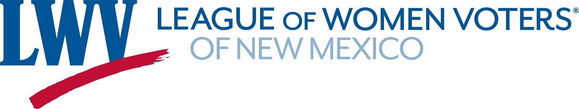

**2019 Legislative Session – The Good, the Bad and the Ugly**

**Note: This article was written as the session ended; the Governor has until April 5th to sign or veto legislation. Any legislation not acted upon is pocket vetoed.**

**The Good and the Bad -** The disposition of League priorities for the session  
HB51 – Decriminalization of Abortion – passed House, lost in Senate – see separate article  
SB688 – State Ethics Commission – won – see separate article – on the Governor’s desk  
HB55 – National Popular Vote – won – expect the Governor to sign it  
This bill pledges New Mexico’s electoral votes to the winner of the national popular vote  
SB672 – Early and Automatic Voter Registration – won – expect the Governor to sign it  
HJR1 – Land Grant Fund for Early Childhood – lost – passed House, but killed in Senate Rules  
SB1 & HB5 – Public Education Changes – won – Additional $450 million in the budget  
HB6 – Tax Changes – The bill that passed the House would have raised $320 million in additional  
revenue and restored fairness to the tax system. The Senate gutted most of that and it went to   
Conference.  It ended up generating only $70 million in additional revenue and doing almost  nothing to restore fairness to the tax system.   
SB416 – Iowa Style Redistricting Model – passed Senate Rules with a unanimous vote, then stalled.  
This was a League-initiated bill and we did not expect it to pass in this session.  
It was part of a longer-term strategy to improve the 2021-22 redistricting process, . Stay tuned.

HM6 & SM11     The League spoke to several committees about the urgent need to fund state outreach efforts ahead of the 2020 Census.  The legislators had not realized the funding concerns with the federal Census effort and the need for state level action.  The big budget bill, HB2, now has about $3.5 million for the effort.

**The Ugly –** The use of “dummy” bills in the Senate.  
Dummy bills are those that are filed after the filing deadline without content. According to the New Mexico Constitution, they are only supposed to be used for emergencies. The League has long been critical of their use.  In the Senate during this session dummy bills were used to pass the State Ethics Commission (SB688) and improve voter registration (SB672). The League supported both of these bills, but that doesn’t mean we support the process. Both the ethics commission and the voter registration bills had House and Senate versions. The House versions had passed that chamber. So why was it necessary to introduce new bills after the filing deadline? The League will continue to be critical of the process.

In balance, the session was a successful one for League priorities despite the losses on reproductive rights, revenue generation and funding for early childhood. Expansion of voting rights, a state ethics commission and expanded funding for education have all been long-standing priorities for the League and we were able to achieve them in this session.

Dick Mason

* * * * * * * * * * * * * * * * * * * * * * * * * * * * *  
To unsubscribe from the RIO-LOBBY list, send any message to [RIO-LOBBY-signoff-request@lists.sierraclub.org](mailto:RIO-LOBBY-signoff-request@lists.sierraclub.org?subject=Unsubscribe+from+RIO-LOBBY&body=SIGNOFF+RIO-LOBBY), or visit [Listserv online](http://lists.sierraclub.org/SCRIPTS/WA.EXE?SUBED1=RIO-LOBBY&A=1). For all the latest news and activities, sign up for [Sierra Club Insider](http://www.sierraclub.org/sierra-club-email/insider), the Club's twice-monthly flagship e-newsletter. Listserv users are subject to the Sierra Club's[Terms and Conditions](http://www.sierraclub.org/terms).

--

you CAN change the world !!  do just one thing today that makes a difference !!  go on, start now !!

--

"The needs of the many outweigh the needs of the few, or the one."  
Spock - Star Trek II

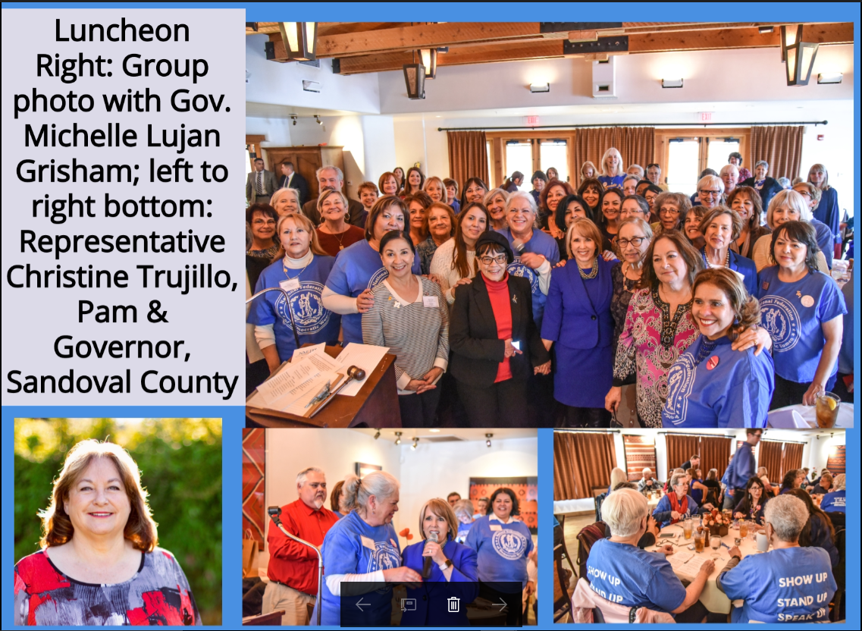

NEW MEXICO FEDERATION DEMOCRATIC WOMEN (NMFDW) The New Mexico Federation of Democratic Women have been recruiting new members as well as getting our membership to renew their dues. Currently we have 10 counties organized and 378 members to date. Our goal is to reach 500+ by the fall meeting. Our State President, Pam Cordova, represented NMFDW at the Opening Ceremonies of the 2019 NM Legislative Session. It was an honor to sit on the floor of the House of Representatives as a guest of the Speaker of the House, and hear our newly elected Democratic Governor give the State of the State Address. NMFDW also participated in what has become the annual Women’s March in Albuquerque, NM; Santa Fe, NM; Las Cruces, NM. In addition the NMFDW was represented at the annual Democratic Party of NM (DPNM) Legislative Dinner held every year in Santa Fe, NM. On February 5, 2019, NMFDW held their Women in Blue Lobby Day at the Roundhouse in Santa Fe, NM. We had 90 in attendance, and we are proud that all 10 counties were represented at our Lobby Day. We started the day by boarding the NM Rail Runner. We arrived in Santa Fe at 9:00 am and headed to the Roundhouse where we were met by our hosts: the Santa Fe Federation of Democratic Women. We all met in the Finance Committee Room and heard legislative news from Senator Mimi Stewart, Majority Whip; freshman Senator Antoinette Sedillo Lopez, and Lt. Governor Howie Morales. Marg Elliston, Chair of the DPNM, joined us on our field trip and also gave us an update on state party news. From there we split up our groups and headed either to the Senate Chamber or the House Chamber. Officers sat in the rostrum and were introduced by Senator Liz Stefanics on the Senate side and Representative Sheryl Stapleton on the House side. From there we headed to our luncheon meeting where our Governor Michelle Lujan Grisham surprised our members with a visit! We all worked very hard to get her elected and were pleased that she took time out of her busy day to join us. We also had the honor of awarding Representative Christine Trujillo with the 2019 Presidents’ Award of Excellence. Our keynote speaker SOS Maggie Toulouse Oliver spoke to us about open primaries. When the luncheon ended members returned to the Roundhouse and we lobbied our representatives to support the NMFDW Resolution that asked the legislature to reestablish and fund the Commission on the Status of Women. We are pleased to say that the Commission was reestablished and funded by our Governor. On February 14, 2019, NMFDW participated with Planned Parenthood’s Respect NM Women at the Roundhouse. More than 150 lobbied the legislators for women’s health rights. Coming up is the annual spring meeting. San Miguel County Federation of Democratic Women will be our hosts. All our county organizations have been busy renewing and recruiting new members, organizing committees, planning events, conducting regular membership meetings, and holding voter registrations. Our southern counties close to the Mexico border have been active in contributing to immigrants in need. We are all discussing the 2020 Presidential Election and preparing for a win in New Mexico!

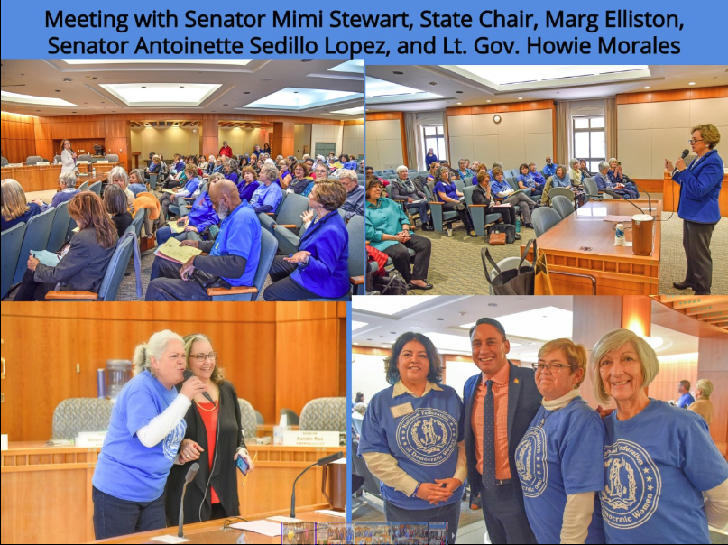

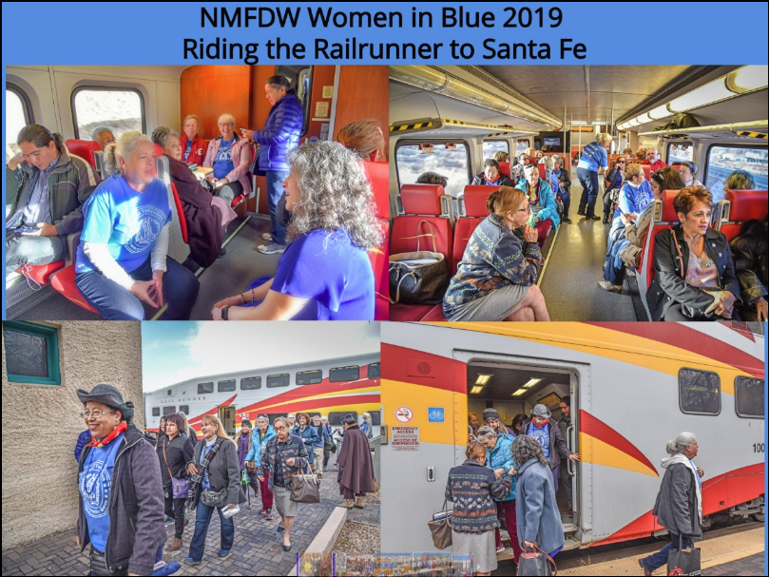

SCFDW – We were not represented at this year’s Women’s March. Next year, we will be!

