March 25, 2020

To whom it may concern:

In this day and age, it has become increasingly difficult to ensure that school aged children have as few socio-economic stressors as possible, allowing effective learning to take place. Desert Programs cannot fill this need alone, and must rely on outside assistance. We would like to extend our gratitude to the St. Paul United Church of Christ, as well as their partners, St. Francis Episcopal Church and the Sandoval County Federation of Democratic Women. The donations and sacrifice that these organizations have been making are a testament to how powerful a strong community can be. These donations have been delivered directly to the families with the greatest need. It is very difficult to put into words the gratitude these children and their families have displayed. Even through this COVID-19 crisis these organizations have answered the call.

During the latest round of deliveries, one parent stated that they had no idea how they were going to feed their children without the donations. Another parent stated that through this time, they had been worried about how to feed their children and the delivery was right in the nick of time.

Many organizations offer to help with anything the kids need. However, very few of these organizations actually follow through. These select organizations did just that. By doing so, they have relieved some of the stress from not only the children in the program, but their parents as well. I would also like to thank Merry Wadsworth and Karen Schafer. Mrs. Wadsworth, having seen the need, had the insight to link these organizations with us. Mrs. Schafer handled all of the logistics for collecting the donations from the various organizations, and collaborated with our program to arrange the supply deliveries.

Thank you again for all you do,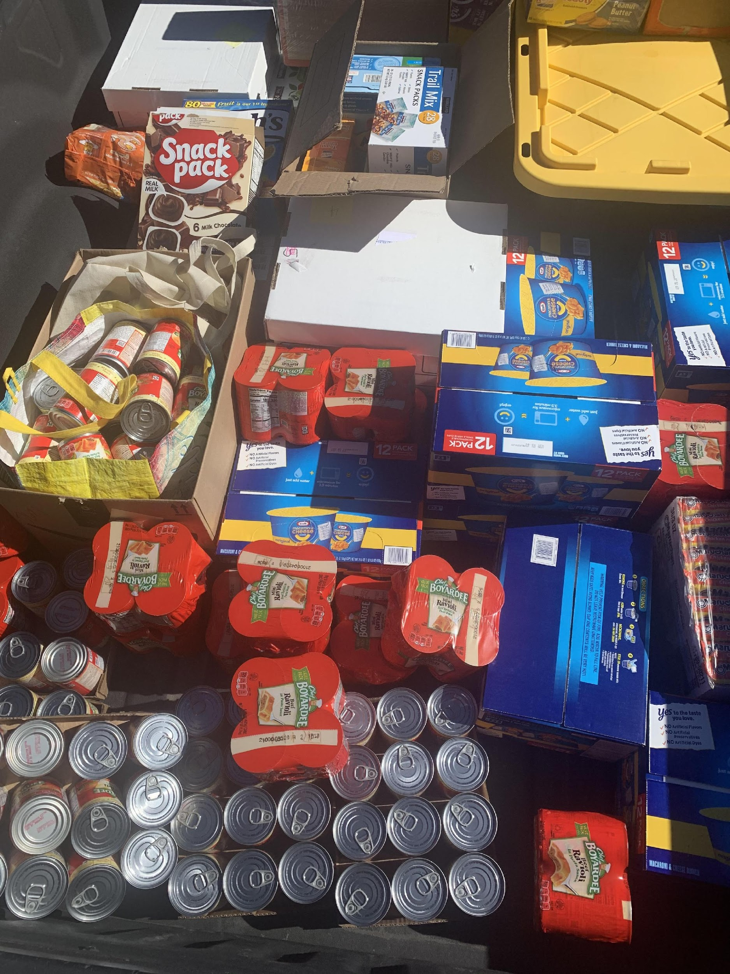

Jarmaine McChriston

School Social Worker

Desert Sunrise Program\*

\**Desert Sunrise Program is a cluster of district supported classrooms designed to work with students who have shown significant social and emotional needs.   The purpose and goal are to support the successful transition of our students back to their home schools.*