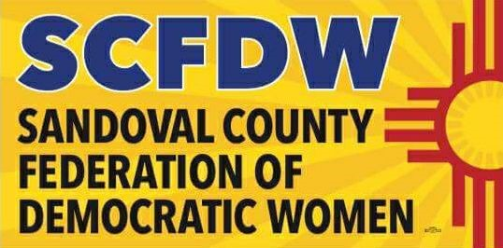

October 5, 2020

The year 2020 has challenged Americans at all levels of our lives. It continues to reveal strengths, limitations, and needs within our families and our neighborhoods. Historically, moments like these find Democratic women stepping forward in support of each other and our communities. With this spirit in mind, the Sandoval County Federation of Democratic Women fulfilled our primary mission of helping to elect Democratic candidates up and down the ballot with the following activities.

* Two of our members, Deb Dapson and Nancy Gloman, continue to sponsor and organize the Sandoval County Second Saturday Lunch; however, since the pandemic, it is completely online via Zoom. Through this medium, they provide pertinent party and campaign updates, as well as bring all Sandoval County informative Democratic celebrity speakers. It also provides a platform for all Democratic candidates to speak to voters.
* Several members also work with county ward leaders to disseminate information about city and county government meetings, as well school board meetings and activities.
* SCFDW worked to fundraise for four county-level candidates who are fellow members, running for county clerk, county treasurer, and two county commission seats. The fundraising was two-fold. First, Karen Schafer composed a letter that was mailed to over four-hundred county Democrats asking for financial support; second, we purchased and sold Biden/Harris yard signs designed specifically for Sandoval County. Both these events were highly successful! We raised more than $7,000 which went directly to the four candidates’ PAC.
* Many SCFDW members are assisting a variety of campaigns with literature drops, text banking, phone banking, writing postcards, and visibility events.
* From February through May, SCFDW collaborated with Feed NM Kids and a local church group to collect food for homeless and at risks students in the community. Hundreds of weekend food packets were bagged and delivered to school counselors for disbursement. After Covid curtailed this activity, we collected money for grocery gift cards, also disbursed by the counselors.
* We submitted the names of ten members to our state organizations, New Mexico Federation of Democratic Women in honor of the 100 anniversary of Women’s Suffrage.
* We printed t-shirts in honor of the 100 year anniversary of Women’s Suffrage and sold them at cost during our annual legislative field trip.
* Every member of the Executive Committee for the Sandoval County Democratic Party is a member of our organization.
* Seven of the candidates on the ballot from Sandoval County in the November 3, 2020 Election are members. Three are not, and another three have districts split between Sandoval and another county.
* During the tenure of the current Executive Board, our membership increased by over 50% from 48 to total of 74 members.
* Presently, SCFDW is in the process of organizing a food drive to benefit Storehouse West, a food pantry located in Rio Rancho.

All members of SCFDW are proud to be representing and supporting the Democratic Party platform and bringing fruition to its ideals. We are a vibrant, active chapter, and we will continue to push forward to help create “a more perfect union.”

In total solidarity,

**Alexandria Piland**

Alexandria Piland

President

Sandoval County Federation of

Democratic Women